XX Years for Resume Data and
Within both job ads and resumes, requested skills and attained skills are listed and standardized for each posting. We identified each skill as either “hard” or “soft” according to XXX.
We selected the three most common professions (in this work, jobs) within job advertisements (via ONEC code), which were identical between our two MSAs: Critical Care Nurses(CCNs), Maintanence and Repair Workers, and Computer Professionals XX. We compiled all skills requested across all advertisements for a profession in the MSA, limiting skills to those found in at least 3% of job postings for that profession.
To identify candidates for a profession—that is, individuals who would likely apply to a job with the same title—we isolated the resumes in an MSA where an individual possessed at least one core skill. A core skill is a relatively defining skill to the profession, and was defined as a hard skill found in at least 30% of job ads for a particular ONEC code, and further limited to those skills which were not widely valued across a number of professions—e.g., skills like “Customer Contact” or “Microsoft Excel” were excluded.
We then compared the skills of each candidate for a profession within the MSA to every job positing in that profession in the MSA.
In total, there were XX job postings and XX resumes within Blacksburg, and XX job postings and XX resumes within Richmond.
Critical Care Nurses
For Critical Care Nurses, there were 266 candidates to 203 resumes in Blacksburg and 267 candidates to 1462 resumes in Richmond. Overall, this suggests that there are somewhat fewer CCN jobs available than potential candidates to fill them in Blacksburg, while the reverse is true in Richmond. There were 4 core skills for CCNs in Richmond: Critical Care Nursing, Advanced Cardiac Life Support, Neonatal Intensive Care Unit, and Patient Care; core skills in Blacksburg were identical but excluded Neonatal Intensive Care Unit.
In terms of skill overlap, the average match of skills a particular job advertisement can hope to achieve was 0.2 in Blacksburg and 0.026 in Richmond, given the disparity in supply on CCNs. The match of each individual to a particular ad ranged from a perfect match (1) to no overlap whatsoever (0). The distribution of skill match of CNN candidates of any education level to individual job ads is shown in Figure 1 for Blacksburg and Figure 2 for Richmond. The distributions have a floor effect, with many people showing no overlap, but several jobs had at least one candidate who had every requested skill.
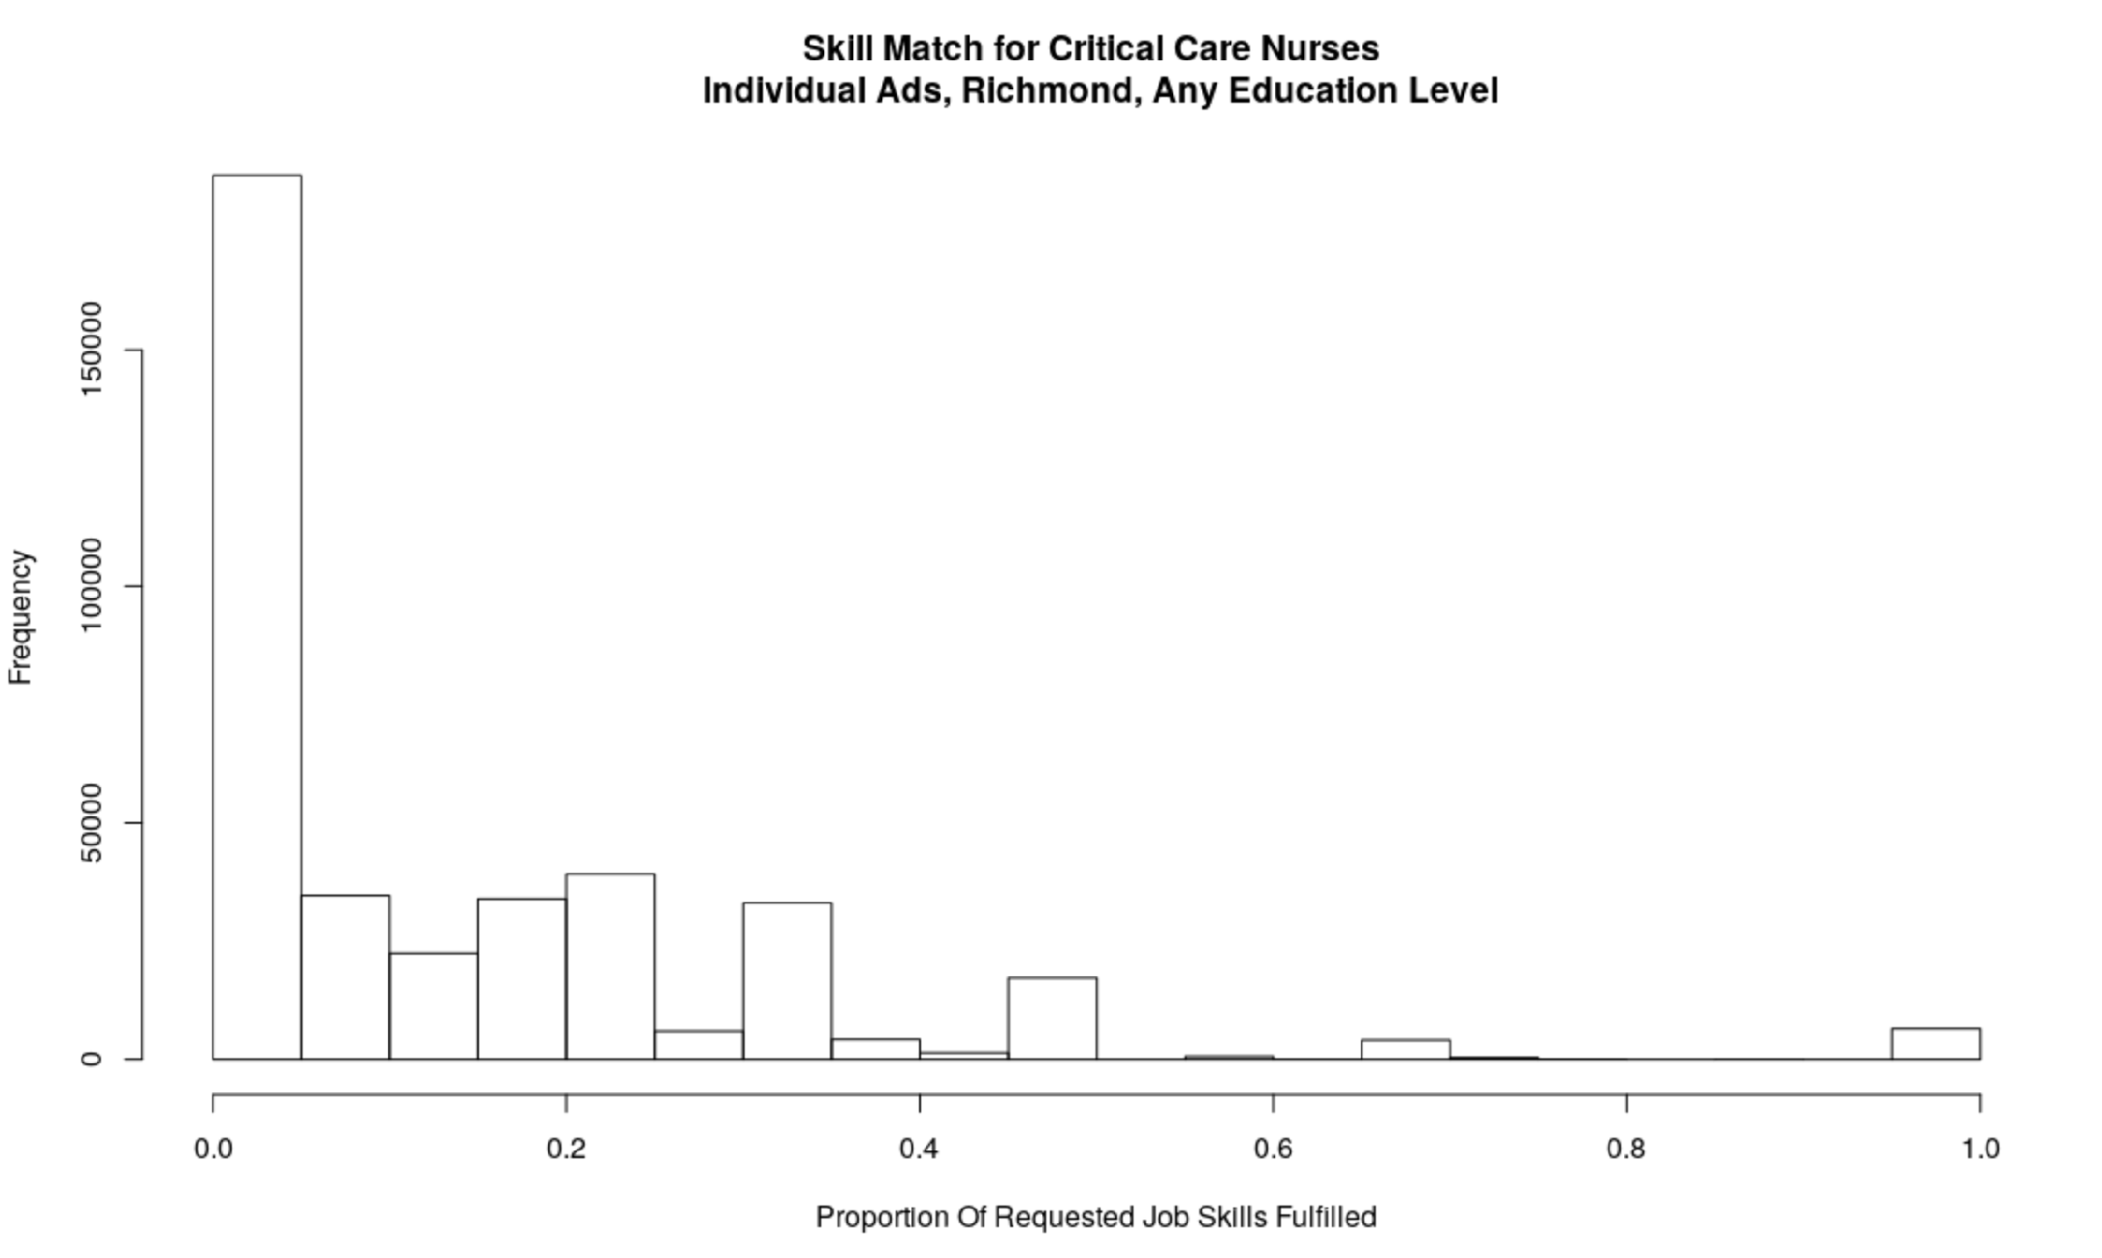
Figure 1
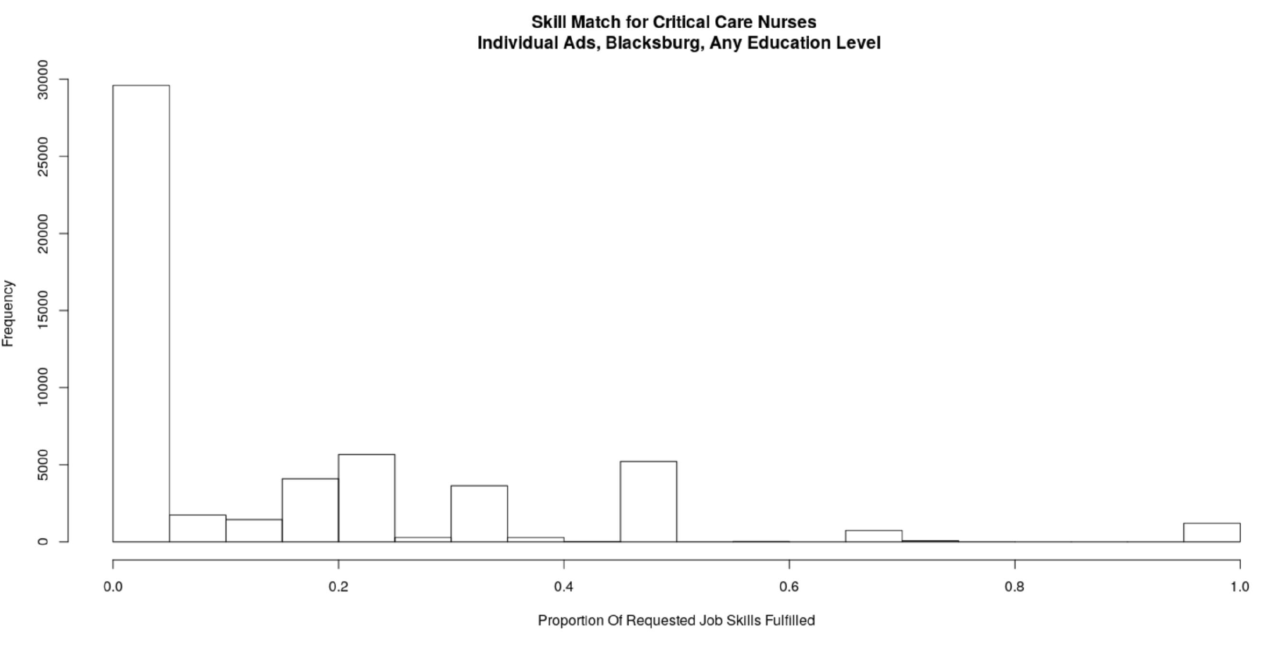
Figure 2
The same graph, showing each candidate’s average match to all job ads on average, is shown in Figure3 for Richmond and Figure 4 for Blacksburg. These graphs show the average proportion of overlap in skills of a particular candidate to a random CCN advertisement within the MSA. Interpretation XX.
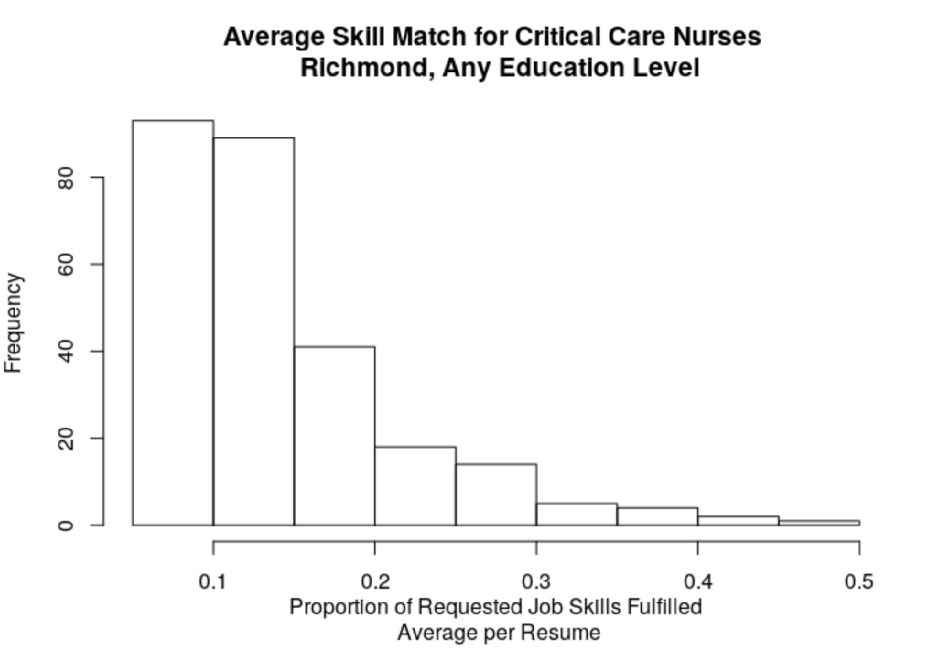
Figure 3
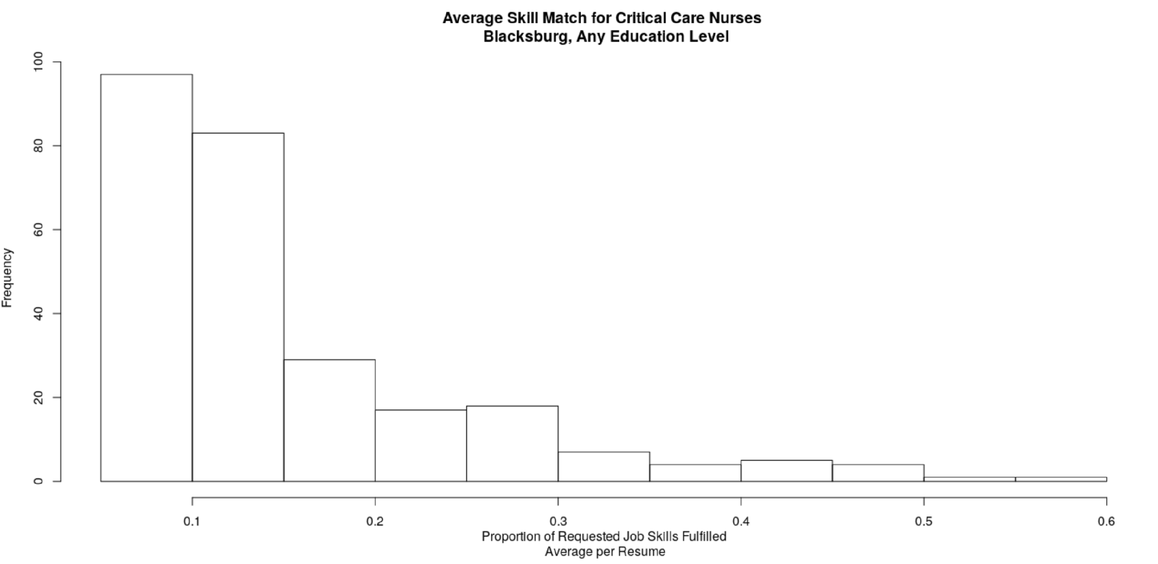
Figure 4
Which skills in particular are especially in demand among employers? Figure 5 illustrates the demand and availability of the top 20 CNN skills in Richmond (See Figure 6 for Blacksburg). The x-axis shows the proportion of ads requesting a particular skill—skills further to the right are more commonly requested. Many ads requested Critical Care Nursing, but less than 10% requested Teaching.
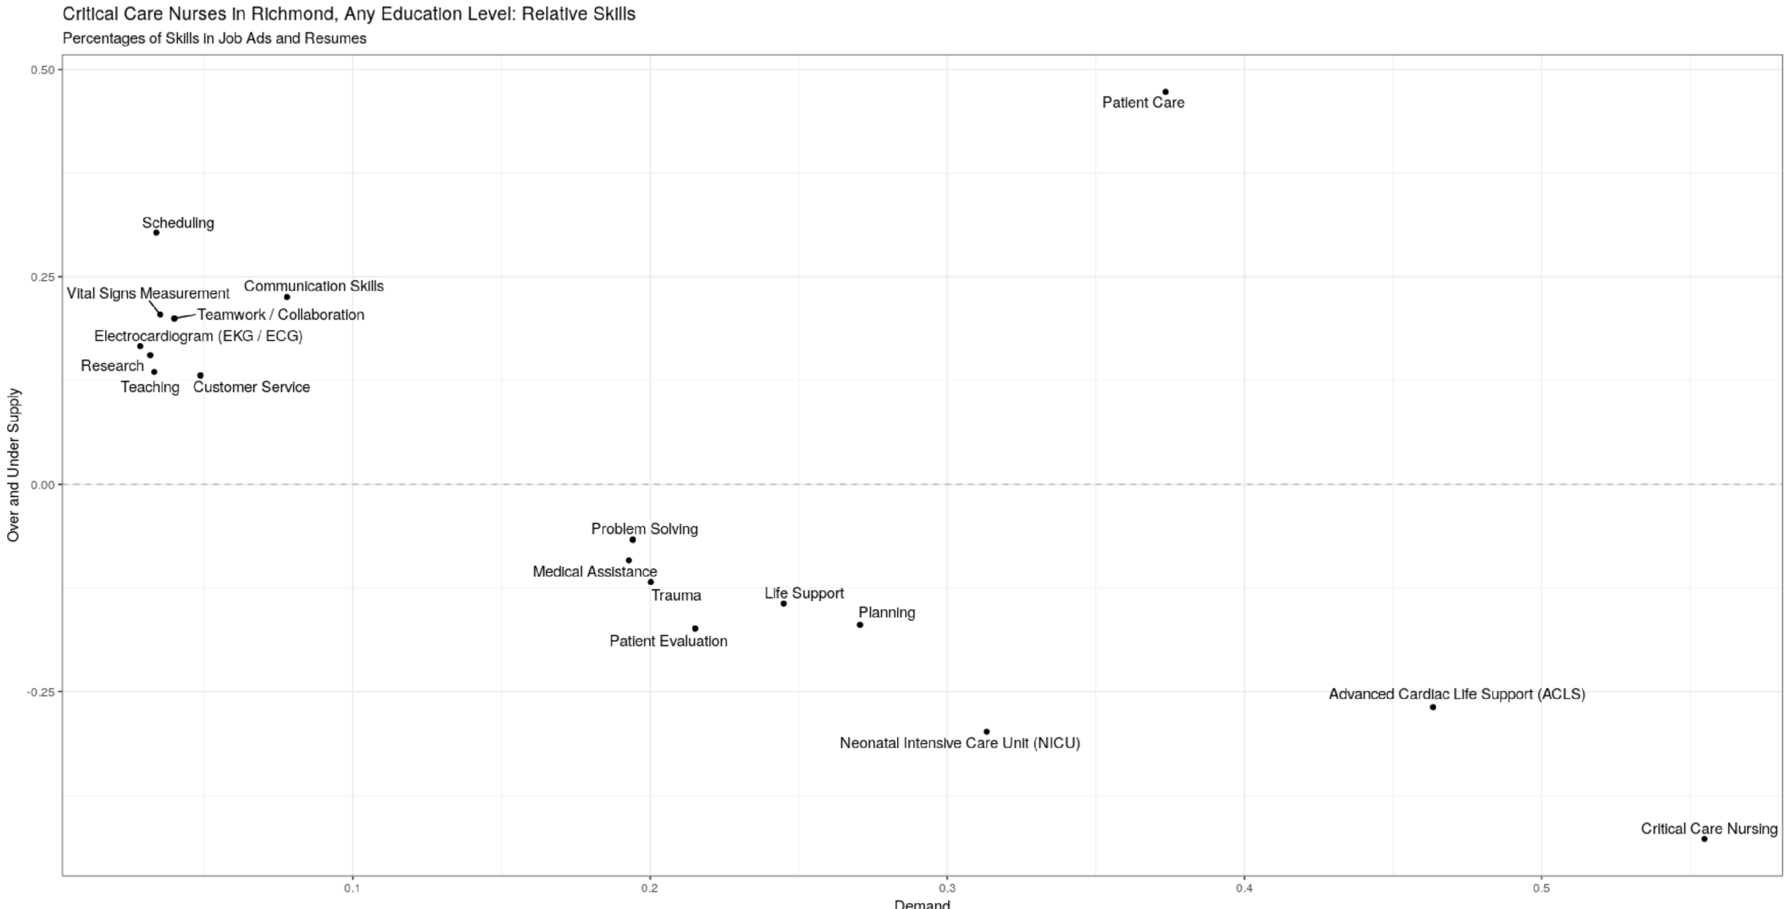
Figure 5
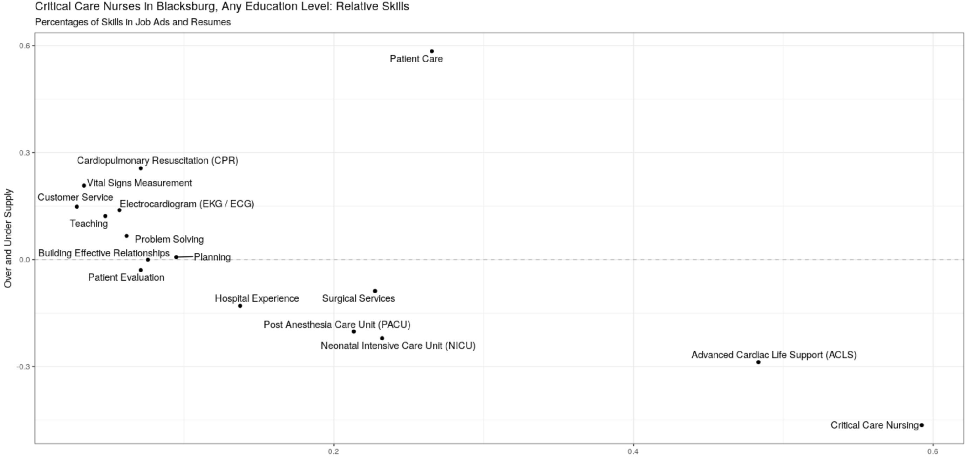
Figure 6
The y-axis shows the availability of a skill compared to demand, using the difference between the proportion of jobs requesting a skill and the proportion of candidates with a particular skill; skills above 0 on the y-axis indicate candidates tend to list this skill more frequently than it is listed in jobs ad (suggesting a larger supply than demand for a skill), and skills below 0 indicate skills that jobs request more frequently than candidates do (suggesting a greater demand for this skill). Less candidates listed Trauma (Richmond) or Surgical Services (Blacksburg) as a skill than job ads, suggesting that amongst job ads, there will be greater competition for candidates with this skill; more candidates listed the Customer Service skill than in job ads, suggesting listing this skill would not significantly favor one candidate over another.
In Richmond, Critical Care Nursing was the skill most often requested for Critical Care Nurses (naturally), but was generally emphasized in more ads than resumes, suggesting there would be more demand and therefore significant competition for candidates with this skill (a similar patterns occurs for two other core skills, Neonatal Intensive Care and Advanced Cardiac Life Support). In contrast, Patient Care is a core skill both often requested but also highly common within resumes, suggesting it is a skill that employers both value but can expect to find in most candidates. Scheduling is a skill that was listed by many candidates, but is rarely requested by job ads, suggesting candidates listing this skill may not significantly increase the likelihood of being hired. A similar pattern occurs for Blacksburg.

